# Cassandra Use Case: Spotify

Spotify would need to have a dataset that keeps track of the number of listens for a given song, as well as some other information. Spotify has a ton of songs, so the scalability of this solution would need to be very large, which is where Cassandra comes in.

The fields would be (Song_title text, Artist text, Album text, Play_count integer)

As you can see, this dataset includes basic information about the song, as well as the number of listens the song has had.

# Queries

1: Songs with over a million listens. 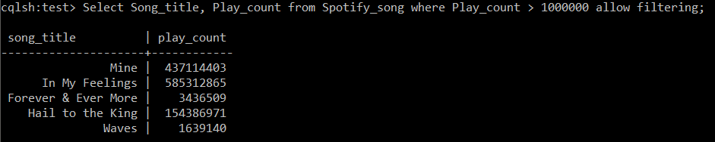

Select Song_title, Play_count from Spotify_song where Play_count > 1000000 allow filtering;

2: The most listened to song.

Select Song_title, MAX(Play_count) from Spotify_song;

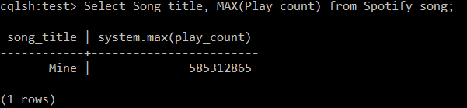

3: Songs by Drake.

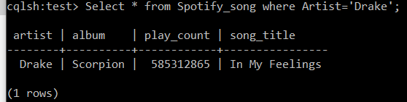Select * from Spotify_song where Artist='Drake';